
SRM Institute of Science and Technology
Mode of Exam
OFFLINE
Faculty of Engineering and Technology
School of Computing
DEPARTMENT OF COMPUTING TECHNOLOGIES
SRM Nagar, Kattankulathur – 603203, Chengalpattu District, Tamilnadu
Academic Year: 2022-2023 EVEN
Test: CLAT-1 Date: 15.02.2023
Course Code & Title: 18CSC305J - Artificial Intelligence Duration: 50 mins
Year & Sem: III/VI Max. Marks: 25 marks
Course Articulation Matrix: (to be placed)

Part - A
(10 x 1 = 10 Marks)
Instructions: Answer all
Q. No | Answer with choice variable | Marks | BL | CO | PO | PI Code
1 | - Perceiving, thinking, and acting | 1 | 1 | 1 | 2 | 2.1.1
2 | - Linear problems | 1 | 1 | 1 | 2 | 2.1.1
3 | - Target based agents | 1 | 1 | 1 | 1 | 1.2.1
4 | - Reaction | 1 | 1 | 1 | 1 | 1.2.1
5 | - Data directed problems | 1 | 1 | 1 | 2 | 2.1.1
6 | - Representing your problem with variable and parameter | 1 | 1 | 1 | 2 | 2.1.2
7 | - Architecture and Program | 1 | 1 | 1 | 2 | 2.1.1
8 | c. Successor function | 1 | 1 | 1 | 1 | 1.2.1
9 | d. iterative | 1 | 1 | 1 | 1 | 1.1.1
10 | - Sensors and Actuators | 1 | 1 | 1 | 1 | 1.1.2
Part – B
(3 x 5 = 15 Marks)
11 | Explain the categories of problems in AI with suitable illustrations.  Ans:  Structured problems–goal state defined  Unstructured problems-goal state not known  Linear problems-based on dependent variable  Nonlinear problems-no dependency between variables | 5 | 1 | 1 | 2 | 2.1.1
12 | Generate state space tree for the following water jug problem.  Given:  Jug 1 – 4 liters of water  Jug 2 – 3 liters of water  Goal state:  Jug 1/Jug 2 – 2 liters of water  Ans:  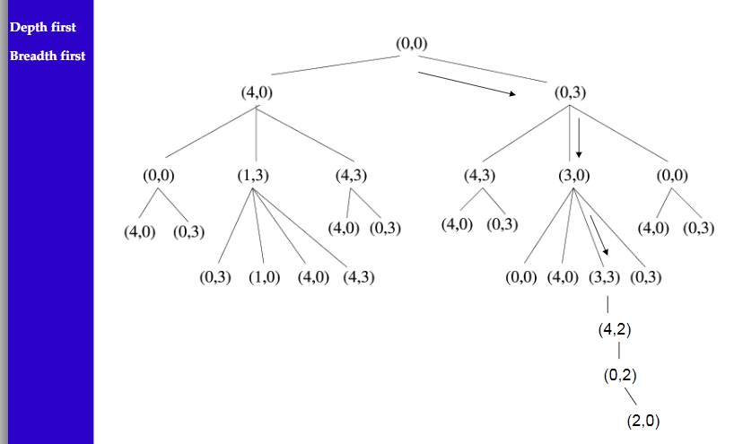 | 5 | 1 | 1 | 2 | 2.4.1
13 | Discuss all the 7 problem characteristics with suitable example.  Ans:  Problem Characteristics:  To choose an appropriate method for a particular Problem:  • Is the problem decomposable?  • Can solution steps be ignored or undone?  • Is the universe predictable?  • Is a good solution absolute or relative?  • Is the solution a state or a path?  • What is the role of knowledge?  • Does the task require human‐interaction? | 5 | 1 | 1 | 2 | 2.1.1
14 | Solve the following crypt arithmetic problem.  FORTY+TEN+TEN=SIXTY  Ans:  Solution:  29786  + 850  + 850  --------  31486  Column 1: N is either 0 or 5. If N=5, then the carry to Col2 is 1 and there is no possible value for E, so N=0.  Column 2: E is either 0 or 5, but N=0, so E=5, and the carry to Col3 is 1.  Column 4: I is either 0 or 1, but N=0, so I=1, O=9, carry from Col3 is 2, and the carry to Col5 is 1.  Column 3: For 1+R+T+T >= 20, R and T must be in {6,7,8}.  Column 5: F+1=S, so {F,S} is either {2,3} or {3,4}, so X is not 3.  Column 3: 1+R+T+T = 22 or 24, so R is odd and must be 7, 2T=14 or 16, T is 7 or 8, but R=7, so T=8, X=4.  Column 5: F=2, S=3.  Column 1: Y=6. | 5 | 1 | 1 | 2 | 2.2.3

Question Paper Setter Approved by Audit Professor/
Course Coordinator

* Performance Indicators are available separately for Computer Science and Engineering in AICTE examination reforms policy.

